Regular Expression in JS
Regular expression (RegEx) is a sequence of characters that defines a search pattern, mainly sed for matching, searching, validating and manipulating string contents.
Regular expression rule-based pattern use to do validation for contents.
Regular expression rules
^ - start the
$ - end with
.- any single character
* 0 or more characters
+ 1 or more characters
? 0 or one character
[] - character
\d- any digits
\w word character

Syntax
let patternData = /pattern/i ignore case

Form Validation

It check all details before pass the data to server side technologies.
Like required field, format of phone number, format of emailId etc.

We can do format validation
Using
- JavaScript
- HTML5 (Internal logic writing in JS).
- React JS form validation

Adv JS function, this keyword, bind, call functions

this keyword : this is a keyword which refer to current object in JS.
The value of this is decided at runtime, not at the time of writing code.
This tells you “who is calling the functions”
This depends on how a function is called, not where it is written.

JS provided 2 pre defined object hierarchy
BOM : Browser object model
DOM : document object model.
Object property
Behavior
Object - property
Behavior
Object

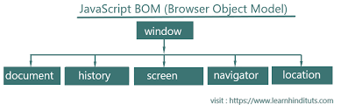

JS provided few pre defined function is call, appy and bind which help to control the value of this inside a functions.

call function : call() invokes the function immediately and accept the argument one by one

functionName.call(this,arg1,arg2,arg3….) it execute immediately
functionName.apply(this,[arg1,arg2,arg3]); it execute immediately
let fun = functionName.bind(this) it execute later
fun(); then it will execute

Tailwind CSS

Course end project

Advanced function in JS

